COPYMASTER |  |  | COPY TONE: Entry Level |  |  |  |  |  |  | VERSION: 1.0
Project Name:  N10-101-MTL |  |  | Product Name:  Acer Nitro 10 |  |  |  |  |  |  | Product Type:  Intel Gaming Desktop
Writer: Clark Gurden |  |  | Central MKT: Sylvia Pan |  |  |  |  |  |  | FCS: 2/E/2026
//AGW Meta Content
Page Title (60) |  |  | Acer Nitro 10 Intel | Compact Gaming Desktop PC
Meta Description (160) |  |  | Run games, stream, and multitask on the Acer Nitro 10 Intel with an Intel® Core™ Ultra 5 processor 125H, an Intel® Arc™ A380 GPU, up to 32 GB DDR5 RAM, and Wi-Fi 6E in a tight 9L chassis.
//Line/Class Content
Shortened KM (120)  Series Card |  |  | A compact 9L gaming desktop with an Intel® Core™ Ultra 5 processor 125H, an Intel® Arc™ A380 GPU, and high-speed Wi-Fi 6E.
//AGW Page Content / Banner
Banner Content - Product Name/Header (40) |  |  | Acer Nitro 10
Banner Content – Description (120)
Key Message/Page Intro
Key Message/Intro (220) |  |  | The Acer Nitro 10 is built for gamers who want to get started with confidence. Its compact design fits easily into everyday setups, delivering smooth gaming performance, modern connectivity, and a flexible foundation you can build on over time.
Copilot+PC/Windows Message |  |  | Windows is fast, powerful, and more secure than ever.  Meet the Computer you can talk to.
CTA Button |  |  | Watch Video
CTA Button Link |  |  | https://youtu.be/dErqF3-2Z-g
Logos / Badges / Awards
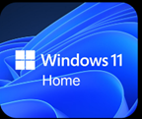 |  |  |  |  |  |  |  |  | 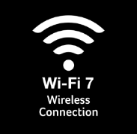  Wi-fi 6E |  |  |  | 
Media Reviews – ENGLISH (ENG)
Publish to USA / CA
Section Headline |  |  | Media Reviews
Text Content
Image Selection |  |  | Generic |  |  | Generic |  |  |  |  | Generic |  |  |  | Generic
Reviewer Name
Quote (180 Characters)
Button & URL |  |  | Read More |  |  | Read More |  |  |  |  | Read More
Partner KSP 1
Image Reference |  |  | 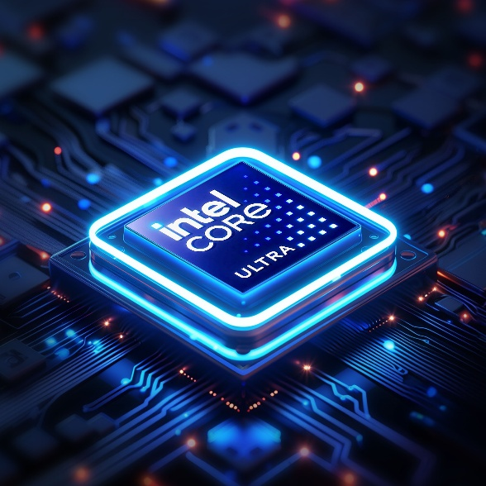
KSP Headline (40) |  |  | Game Without Compromise
KSP Body (250) |  |  | Intel® Core™ Ultra processors feature newly optimized hybrid architecture and industry leading technology that enables you to go beyond gaming and creation.
Overline (20) |  |  |  |  | Up to Intel® |  |  | Up to |  |  |  |  |  | Up to
Spec (30) |  |  | Windows 11 Home |  | Core™ Ultra 5 |  |  | 14 Cores |  |  |  |  |  | 4.5 Ghz
Underline (20) |  |  | Operating System |  | processor 125H |  |  | 4P + 8E + 2LPE |  |  |  |  |  | P-core Max Turbo Freq.
Partner KSP 2
Image Reference |  |  | 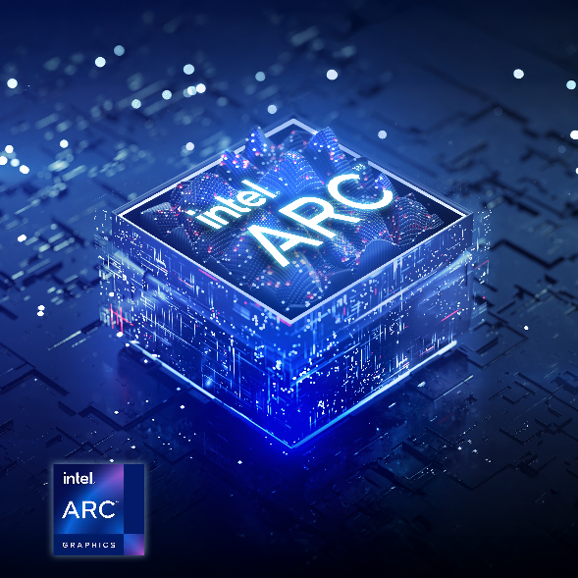
KSP Headline (40) |  |  | A New Stage of the Game
KSP Body (250) |  |  | The Intel® Arc™ A380 GPU brings smooth 1080p gaming, AI-enhanced upscaling with XeSS, and advanced media features like AV1 hardware encoding—all in an affordable, modern graphics card built for gamers and creators ready to step up their experience.
Acer KSP 1 (Design)
KSP Headline (40) |  |  | 9L of Focused Firepower
KSP Body (250) |  |  | This 9L chassis saves desk space without compromising functionality. Smart airflow, bold styling, and clean cable routes make it perfect for dorm rooms, workstations, or compact battle stations.
Overline (20) |  |  | Compact |  |  |  | Up To |  |  |  |  | Up to
Spec (30) |  |  | 9L Chassis |  |  |  | 32GB DDR5 RAM |  |  |  |  | 1TB M.2 PCIe SSD + 1TB HDD
Acer KSP 2
KSP Headline (40) |  |  | Load Fast, React Faster
KSP Body (250) |  |  | Up to 32 GB of DDR5 5600 MT/s RAM and PCIe Gen 4 SSDs give you near-instant boots, seamless loads, and zero delay under pressure.
Acer KSP 3
Image reference |  |  | 
Logos (to be placed in main ksp graphic) |  |  | or   (choose one)  (PLACE correct Wi-FI type below wi-fi graphic, aka 6E, 7, etc.)
KSP Headline (40) |  |  | Fast, Reliable Connectivity
KSP Body (250) |  |  | Wi-Fi 6E helps keep gameplay, streaming, and downloads stable in busy networks. A wide selection of ports makes it easy to connect peripherals, displays, and storage, keeping your setup ready for whatever you plug in next.
KSP
KSP Headline (40) |  |  | Acer Intelligence Space
KSP Body (180 |  |  | Launch smarter performance through Acer Intelligence Space, your hub for AI-ready tools and hardware insights that fuel productivity, creativity, and gaming
USE US or WW KSP – GO LIVE 3/1/26
NEW MS PARTNER KSP (US)
KSP Headline |  |  | Play 200+ Games on Your Windows 11 PC
KSP Body |  |  | Play The Outer Worlds 2, Forza Horizon 5, and 200+ more games on your new Acer Nitro Windows 11 PC with 2 months of Xbox Game Pass Premium. New Xbox published games join the library within 1 year of launch. Dive into a range of legendary franchises from Call of Duty to Minecraft and everything in between. Get in-game benefits for the biggest games like League of Legends, Call of Duty: Warzone, Rainbow Six Siege, and more. Play and earn up to $50 a year in the Store with Rewards. Find your community with Xbox and play anywhere you want
NEW MS PARTNER KSP (WW)
KSP Headline |  |  | Play 200+ Games on Your Windows 11 PC
KSP Body |  |  | Play The Outer Worlds 2, Forza Horizon 5, and 200+ more games on your new Acer Nitro Windows 11 PC with 2 months of Xbox Game Pass Premium. New Xbox published games join the library within 1 year of launch. Explore a range of global franchises from Minecraft to Halo and everything in between. Get in-game benefits for the biggest games like League of Legends, Call of Duty: Warzone, Rainbow Six Siege, and more. Play and earn up to 50,000 points per year with Rewards. Find your community with Xbox and play anywhere you want.
Disclaimers
 | This product is not designed for cryptocurrency mining uses. Damages to your product arising from cryptocurrency mining or related activities are excluded from your product’s warranty.
 | The terms HDMI and HDMI High-Definition Multimedia Interface and the HDMI Logo are trademarks or registered trademarks of HDMI Licensing Administrator, Inc. in the United States and other countries.
 | Specifications may vary depending on model and/or region. All models subject to availability
Intel® technologies’ features and benefits depend on system configuration and may require enabled hardware, software, or service activation. Performance varies depending on system configuration. No product or component can be absolutely secure.

© Intel Corporation. Intel, the Intel logo, and other Intel marks are trademarks of Intel Corporation or its subsidiaries. Other names and brands may be claimed as the property of others.
 | All information provided is subject to change at any time, without notice. Intel may make changes to manufacturing life cycle, specifications, and product descriptions at any time, without notice. The information herein is provided ‘as-is’ and Intel does not make any representations or warranties whatsoever regarding accuracy of the information, nor on the product features, availability, functionality, or compatibility of the products listed.
 | Max Turbo Frequency is the maximum single-core frequency at which the processor is capable of operating using Intel® Turbo Boost Technology and, if present, Intel® Turbo Boost Max Technology 3.0 and Intel® Thermal Velocity Boost. Frequency is typically measured in gigahertz (GHz), or billion cycles per second.
 | Intel® Turbo Boost Max Technology 3.0 identifies the best performing core(s) on a processor and provides increased performance on those cores through increasing frequency as needed by taking advantage of power and thermal headroom. Intel® Turbo Boost Max Technology 3.0 frequency is the clock frequency of the CPU when running in this mode.
 | Maximum P-core turbo frequency derived from Intel® Turbo Boost Technology.
 | P refers to Performance-cores, E refers to Efficient-cores, and LPE refers to Low Power Efficient-cores
 | AI features may require software purchase, subscription or enablement by a software or platform provider, or may have specific configuration or compatibility requirements. Details at www.intel.com/aipc.
 | ©2026 NVIDIA Corporation. NVIDIA, the NVIDIA logo, GeForce, and GeForce RTX are registered trademarks and/or trademarks of NVIDIA Corporation in the United States and other countries. All other trademarks and copyrights are the property of their respective owners.
 | Memory limits depend on the OS. For details on Windows 11 Home and other versions, visit Microsoft Learn: https://learn.microsoft.com/en-us/windows/win32/memory/memory-limits-for-windows-releases.
 | Claim within 30 days of device activation. New and eligible returning members only. Valid payment method required. Subscription continues automatically at regular monthly price unless cancelled. Subject to xbox.com/subscriptionterms. New Call of Duty titles will join the library at least 12 months after launch. Benefits vary by Xbox Game Pass plan. Game library varies over time, by region, device, and Xbox Game Pass plan. xbox.com/gamepass. In-game benefits vary by game, region, and over time. Game must be installed to access in-game benefits. Xbox Cloud Gaming requires an Xbox Game Pass subscription and supported device (both sold separately). Cloud playable games not included with Xbox Game Pass are sold separately, and may be made available with Xbox Game Pass in the future. See library: xbox.com/play. Stream directly on Xbox consoles, or with the Xbox app or at xbox.com/play on supported devices. Select regions (xbox.com/regions) and devices (xbox.com/cloud-devices). Rewards: Terms apply. Microsoft Account required. Select markets only. Rewards vary by Game Pass Plan and Rewards Level. Point values vary by local market currency, Rewards level, and the number of points redeemed. Point multipliers compared to Game Pass Essential earning potential. Gameplay rewards for 18+. Exclusive quests with Premium and Ultimate plans only, for titles in the Game Pass library. Qualifying purchases at Microsoft Store (online, or on Windows or console) at Rewards with Xbox.

